Objective: Linearize and simulate an energy balance model with radiative and convective heat transfer.
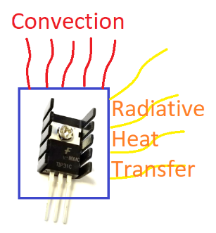
An energy balance equation includes convective and radiative heat transfer and is nonlinear because of the T⁴ term.
$$\frac{dT}{dt}=f\left(T, Q\right)=\frac{UA\left(T_{a}-T\right)+εσA\left(T_{∞}^{4}-T^{4}\right)+αQ}{mc_{p}}$$
Linearize the nonlinear differential equation by computing the partial derivatives γ and β with respect to the heater value (Q) and temperature (T). The γ and β are constants when evaluated at steady state conditions. The right hand side of the differential equation is a function f(T,Q) of only Q and T while the other values are constants.
$$\frac{dT}{dt}=f\left(T, Q\right)≈{\left.\frac{∂f}{∂T}\right|}_{x_{0}}∙\left(T-T_{0}\right)+{\left.\frac{∂f}{∂Q}\right|}_{x_{0}}∙\left(Q-Q_{0}\right)$$
Condensed Linear Form
$$\frac{dT}{dt}≈γ\left(T-T_{0}\right)+β\left(Q-Q_{0}\right)$$
with partial derivatives evaluated at steady state conditions ($Q_{0}=0, T_{0}=23℃$):
$$γ={\left.\frac{∂f}{∂T}\right|}_{x_{0}}$$
$$β={\left.\frac{∂f}{∂Q}\right|}_{x_{0}}$$
Use values:
- α=0.01
- Ta=23ºC
- m=0.004 kg
- ε=0.9
- A=0.0012 m²
- cp=500 J/kg-K
- U=5 W/m²-K
- σ=5.67x10⁻⁸ W/m²-K⁴
- T∞=23 ºC
to simulate the change in temperature over the 5 minutes when heater Q is adjusted to 75%. Compare the simulated temperature response to data from the TCLab as well as the nonlinear model. Add the linear simulation prediction to the solution from the prior TCLab exercise.
Solution
$$\frac{dT}{dt}≈γ\left(T-T_{0}\right)+β\left(Q-Q_{0}\right)$$
$$γ={\left.\frac{∂f}{∂T}\right|}_{x_{0}}=-\frac{UA}{mc_{p}}-\frac{4εσA}{mc_{p}}{T_{0}}^{3} \\ β={\left.\frac{∂f}{∂Q}\right|}_{x_{0}}=\frac{α}{mc_{p}}$$

